EXPERIMENT 3

CREATE
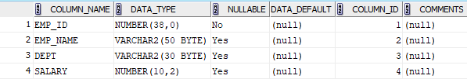

INSERT
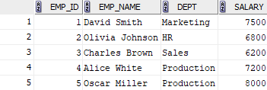

1.Select employees with salaries greater than 7000
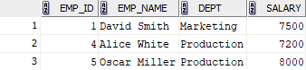

2.Update the salary of 'David Smith' to 8200.00
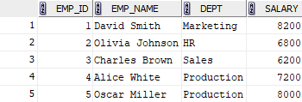

3.Insert a new employee with Emp_id = 6, Emp_name = 'Daniel Harris', Dept = 'Production', and Salary = 6700.00
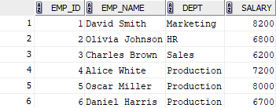

4. Delete the employee with Emp_id = 3 ('Charles Brown')
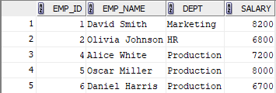

5. Select employees whose names do not start with 'D' or 'O.'
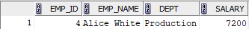

6. Calculate the total salary expense for each department.
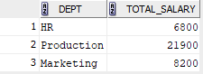

7.Update the salary of employees in the 'Production' department by adding 5% to their current salaries.
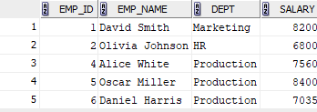
8.Delete all employees with salaries below 7000.
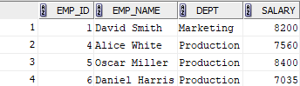

9. Find the employee with the lowest salary and display their name and salary.
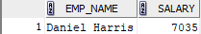

10.Update the salary of employees in the 'Marketing' department to 8200.00.
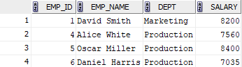
11. Find the names of all employees starting with the alphabet 'A':
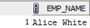

12. List the names of all employees whose empname contains the substring 'it':
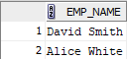
13. List all departments in Upper Case Format
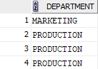
14. List the employee details whose department starts with 'M', with the 3rd letter as 'r', and containing the substring 'ket':
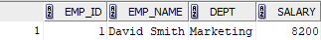

15. List all departments in reverse in uppercase format (avoid duplicates)
